

CCE-II CASE STUDY REPORT
MUSIC PLAYLIST MANAGER USING DOUBLY LINKED LIST
Submitted by
1. Salve Alisha Navnath(266)
2. Tapase Pooja Santosh(253)
3. Salve Shraddha Kishor(239)
4. Peherkar Payal Vijay(3239)
5. Najan Pranita Sopan(217)
Submitted to: Dr.Rahane Sir
Academic Year: 2026–2027

Certificate
This is to certify that the case study report titled “Music Playlist Manager Using Doubly Linked List” has been prepared by the above students of S.Y. B. Tech, Electronics and Computer Engineering, as part of the DSA CCE-II activity for Semester III.
Faculty Signature: ____________________ Date: ______________

Acknowledgement
We sincerely thank our DSA faculty for assigning this practical case study. The supplied reference implementation helped us understand node structure and pointer manipulation. This activity connects classroom concepts with C++ programming, testing, debugging, and version control.

Abstract
This project implements a menu-driven C++ Music Playlist Manager using a doubly linked list. Every node stores a song title, artist, and prev/next links. The head pointer identifies the first song, while current identifies the selected song. The application supports adding and deleting songs, forward and reverse display, current/next/previous navigation, complete playlist traversal, and repeat-all. Empty-list and first/last-song boundary conditions are handled. Diagrams, algorithms, test cases, complexity analysis, GitHub workflow, viva questions, and source code are included.

Contents
- 1. Introduction and problem statement
- 2. Objectives and requirements
- 3. Data structure and pointer roles
- 4. Diagrams
- 5. Algorithms and implementation
- 6. Testing and validation
- 7. Complexity analysis
- 8. VS Code and GitHub workflow
- 9. Limitations and future enhancements
- 10. Conclusion
- 11. Viva questions
- Appendix A: C++ source code

1. Introduction and Problem Statement
A music player lets users organize songs and navigate between tracks. A doubly linked list is suitable because each node links to both its previous and next node. This project asks us to implement a menu-driven music playlist where users can add, delete, display, and play songs sequentially, move both forward and backward, repeat the playlist, and demonstrate pointer operations with diagrams. The program simulates playback through console messages; it does not play audio.

2. Objectives and Functional Requirements
- Represent each song with a Node containing title, artist, prev, and next.
- Use head for the first song and current for the selected song.
- Use p for a new/deleted node and q as a traversal pointer, following the supplied naming convention.
- Implement add, delete, forward/reverse display, current/next/previous, play-all, and repeat-all.
- Handle an empty list, one song, missing titles, and navigation at either end.
- Test in VS Code and maintain source code and progress in GitHub.
Menu options: 1 Add Song; 2 Delete Song; 3 Display Playlist; 4 Display Playlist in Reverse; 5 Play Current Song; 6 Play Next Song; 7 Play Previous Song; 8 Play Complete Playlist; 9 Repeat All; 10 Show Current Song; 11 Exit.

3. Data Structure and Pointer Roles
Field / pointer | Purpose
title, artist | Song information stored in each node.
prev | Points to the previous node; nullptr at the first node.
next | Points to the next node; nullptr at the last node.
head | Points to the first song.
current | Points to the selected/playing song.
p | Points to a newly allocated node or node to delete.
q | Temporary pointer used to traverse the list.
Link invariant: if A->next is B, then B->prev must be A. The first node has prev = nullptr and the last node has next = nullptr.

4. System Design and Diagrams

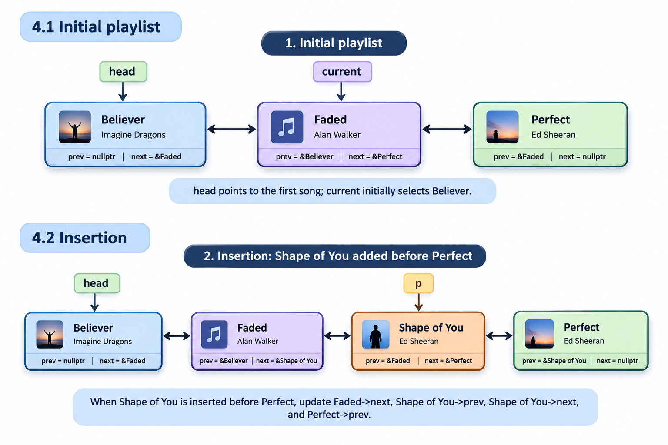

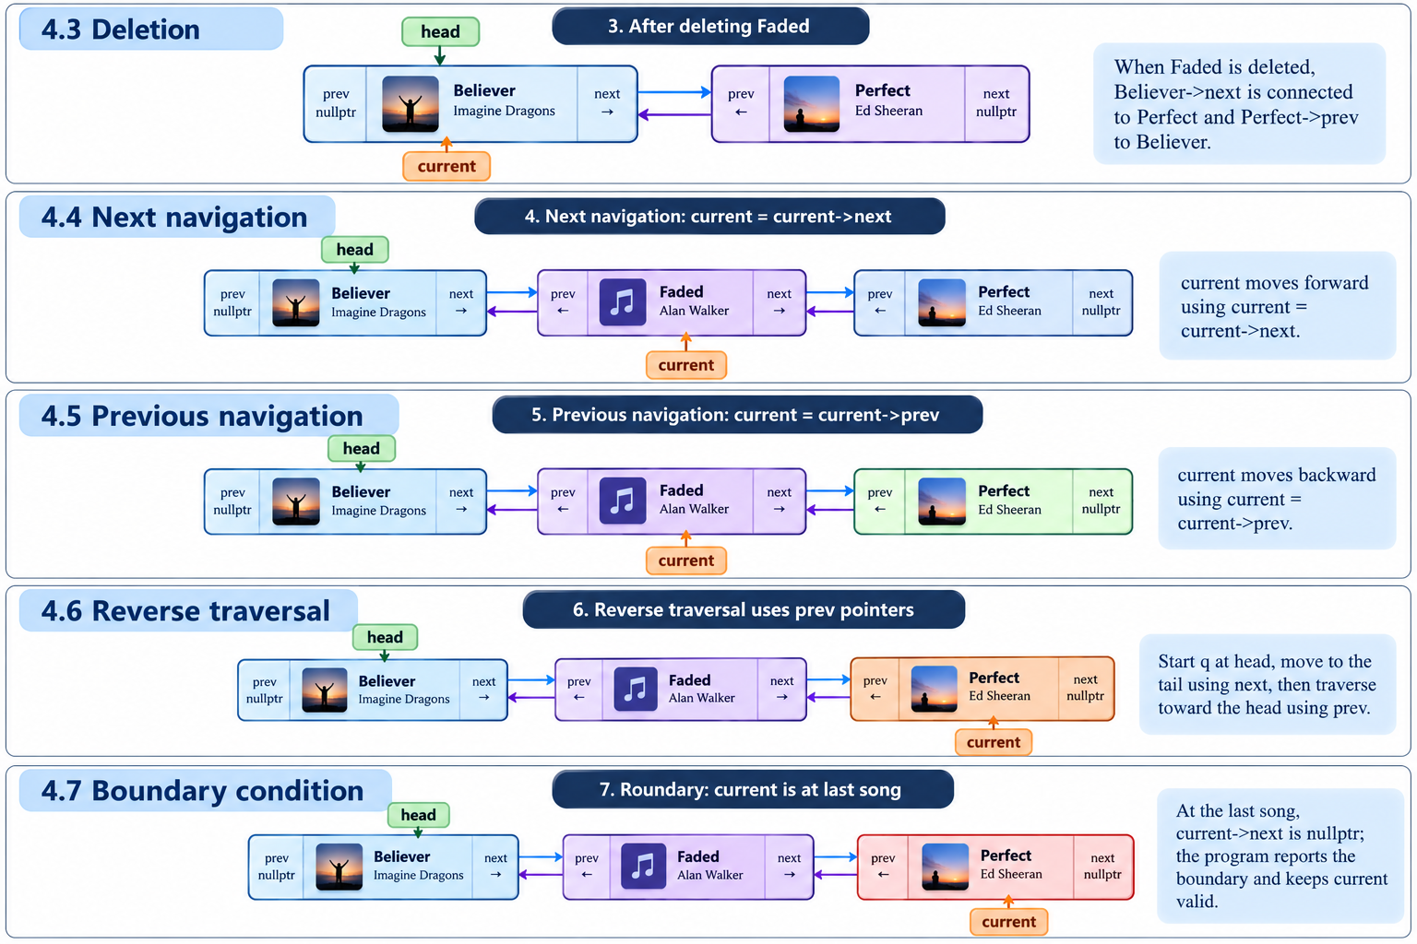

5. Algorithms and Implementation

5.1 Add Song
- Create node p with title and artist.
- If head is nullptr, set head = p and current = p.
- Otherwise traverse from head using q until q->next is nullptr.
- Set q->next = p and p->prev = q.

5.2 Delete Song
- Traverse with q until the title matches or q becomes nullptr.
- If not found, display a message and leave the list unchanged.
- Store the matching node in p.
- Reconnect p->prev->next and p->next->prev where those neighbours exist; update head when deleting the first node.
- If current is deleted, select the next node if available, otherwise the previous node.
- Delete p and set current to nullptr if the list becomes empty.

5.3 Navigation and Repeat All
For Next, verify current exists and current->next is not nullptr before moving. For Previous, verify current exists and current->prev is not nullptr. Repeat All validates the repetition count and starts traversal from head for each repetition.
Memory management: new creates nodes and delete releases removed nodes. The destructor releases all remaining nodes when the playlist object is destroyed. Deletion uses song title as the key, so duplicate titles are ambiguous; the first match is deleted.

6. Testing and Validation
Execute these tests in VS Code and record actual output/screenshots before submission. The results below are expected outcomes, not a claim that the program has already been tested on your computer.
Test | Action | Expected outcome
Empty playlist | Display/play/next/previous/repeat | Safe empty-list message; no crash.
One song | Add one; choose Next and Previous | Current is set; both boundaries handled.
Multiple songs | Add at least three | Forward and reverse orders are correct.
Add later | Add another song after several songs | New song is linked at the tail.
Delete first | Delete head song | head updates; new head->prev is nullptr.
Delete middle | Delete an interior song | Adjacent nodes reconnect both ways.
Delete last | Delete tail song | New tail->next is nullptr.
Missing title | Delete unknown title | Not-found message; list unchanged.
Navigation | Next then Previous | current changes by one node.
Next at last | Select Next at tail | Boundary message; current remains valid.
Previous at first | Select Previous at head | Boundary message; current remains valid.
Repeat all | Use a positive repetition count | Each repetition starts from head.
Exit | Choose option 11 | Menu exits cleanly.

7. Complexity Analysis
Operation | Complexity | Reason
Add at tail | O(n) | Must traverse to the last node.
Delete by title | O(n) | May inspect every node.
Forward/reverse display | O(n) | Visits nodes; reverse first finds the tail.
Next/Previous | O(1) | Follows one link.
Show current | O(1) | Reads current node.
Storage | O(n) | One node per song.

8. VS Code and GitHub Workflow
- Create a folder named MusicPlaylistManager and open it in VS Code.
- Save the program as main.cpp.
- Compile with a C++ compiler, for example: g++ main.cpp -o playlist.
- Run the program and complete the test plan; fix errors and capture screenshots.
- Create a GitHub repository and add main.cpp, README.md, diagrams, and the report if required.
- Commit progress regularly with meaningful messages such as “Add node structure”, “Implement deletion”, and “Add navigation and tests”.

9. Limitations and Future Enhancements
- The current program simulates playback in the console; it does not play audio files.
- Songs are held in memory and are lost when the program exits.
- Deleting by title is ambiguous if duplicate song titles exist.
- Future improvements: unique song IDs, file-based save/load, search/edit, shuffle, and a GUI/audio-library integration.

10. Conclusion
The Music Playlist Manager demonstrates node creation, insertion, deletion, traversal, bidirectional navigation, and current-node management using a doubly linked list. The head pointer locates the first song, current tracks the selected song, and prev/next links enable movement in both directions. Boundary checks and careful pointer reconnection make the program more reliable. The case study also introduces practical testing and version-control habits.

11. Viva Questions with Answers
What is a doubly linked list? A list where each node links to both previous and next nodes.
Why use it for a playlist? It supports Next and Previous navigation.
What does head point to? The first node.
What is current? The currently selected song node.
What are p and q? p identifies a new/deleted node; q traverses.
Why is head->prev nullptr? The first node has no predecessor.
Why is tail->next nullptr? The last node has no successor.
What must be changed when deleting a middle node? The previous node’s next and next node’s prev links.
Time complexity of Next? O(1).
What if Next is selected at the last song? Show a boundary message and do not move current.
Why use a destructor? To release remaining dynamically allocated nodes.

Appendix A – C++ Source Code
Compile and test this source in your own VS Code environment before final submission.

#include <iostream>
#include <string>
#include <limits>
using namespace std;

class Node {
public:
string title;
string artist;
Node* prev;
Node* next;

Node(string t, string a) {
title = t;
artist = a;
prev = nullptr;
next = nullptr;
}
};

class MusicPlaylist {
private:
Node* head;
Node* current;

public:
MusicPlaylist() {
head = nullptr;
current = nullptr;
}

MusicPlaylist() {
Node* temp = head;

while (temp != nullptr) {
Node* p = temp;
temp = temp->next;
delete p;
}
}

void addSong(string title, string artist) {
Node* p = new Node(title, artist);

if (head == nullptr) {
head = p;
current = p;
cout << "First song added!\n";
return;
}

Node* q = head;

while (q->next != nullptr) {
q = q->next;
}

q->next = p;
p->prev = q;

cout << "Song added successfully!\n";
}

void displayForward() {
if (head == nullptr) {
cout << "Playlist is empty.\n";
return;
}

Node* q = head;

cout << "\n--- Music Playlist ---\n";

while (q != nullptr) {
cout << q->title << " - " << q->artist << "\n";
q = q->next;
}
}

void displayReverse() {
if (head == nullptr) {
cout << "Playlist is empty.\n";
return;
}

Node* q = head;

while (q->next != nullptr) {
q = q->next;
}

cout << "\n--- Reverse Playlist ---\n";

while (q != nullptr) {
cout << q->title << " - " << q->artist << "\n";
q = q->prev;
}
}

void showCurrent() {
if (current == nullptr) {
cout << "No current song. Playlist is empty.\n";
return;
}

cout << "Current song: "
<< current->title << " - "
<< current->artist << "\n";
}

void nextSong() {
if (current == nullptr) {
cout << "Playlist is empty.\n";
}
else if (current->next == nullptr) {
cout << "Already at the last song.\n";
}
else {
current = current->next;
showCurrent();
}
}

void previousSong() {
if (current == nullptr) {
cout << "Playlist is empty.\n";
}
else if (current->prev == nullptr) {
cout << "Already at the first song.\n";
}
else {
current = current->prev;
showCurrent();
}
}

void deleteSong(string title) {
Node* q = head;

while (q != nullptr && q->title != title) {
q = q->next;
}

if (q == nullptr) {
cout << "Song not found.\n";
return;
}

Node* p = q;

if (p->prev != nullptr) {
p->prev->next = p->next;
}
else {
head = p->next;
}

if (p->next != nullptr) {
p->next->prev = p->prev;
}

if (current == p) {
if (p->next != nullptr) {
current = p->next;
}
else {
current = p->prev;
}
}

delete p;

if (head == nullptr) {
current = nullptr;
}

cout << "Song deleted successfully!\n";
}

void playAll() {
if (head == nullptr) {
cout << "Playlist is empty.\n";
return;
}

Node* q = head;

while (q != nullptr) {
cout << "Playing: "
<< q->title << " - "
<< q->artist << "\n";

q = q->next;
}
}

void repeatAll(int n) {
if (head == nullptr) {
cout << "Playlist is empty.\n";
return;
}

if (n < 1) {
cout << "Repetitions must be at least 1.\n";
return;
}

for (int i = 1; i <= n; i++) {
cout << "\nRepeat " << i << ":\n";
playAll();
}
}
};

int main() {
MusicPlaylist list;
int choice;

do {
cout << "\n===== MUSIC PLAYLIST MANAGER =====\n";
cout << "1. Add Song\n";
cout << "2. Delete Song\n";
cout << "3. Display Playlist\n";
cout << "4. Display Playlist in Reverse\n";
cout << "5. Show Current Song\n";
cout << "6. Play Next Song\n";
cout << "7. Play Previous Song\n";
cout << "8. Play Complete Playlist\n";
cout << "9. Repeat All\n";
cout << "10. Exit\n";
cout << "Enter your choice: ";

if (!(cin >> choice)) {
cout << "Invalid input. Exiting.\n";
return 0;
}

cin.ignore(numeric_limits<streamsize>::max(), '\n');

string title, artist;

switch (choice) {
case 1:
cout << "Enter song title: ";
getline(cin, title);

cout << "Enter artist name: ";
getline(cin, artist);

list.addSong(title, artist);
break;

case 2:
cout << "Enter title to delete: ";
getline(cin, title);

list.deleteSong(title);
break;

case 3:
list.displayForward();
break;

case 4:
list.displayReverse();
break;

case 5:
list.showCurrent();
break;

case 6:
list.nextSong();
break;

case 7:
list.previousSong();
break;

case 8:
list.playAll();
break;

case 9: {
int n;

cout << "Enter repetition count: ";

if (!(cin >> n)) {
cout << "Invalid repetition count.\n";
cin.clear();
cin.ignore(
numeric_limits<streamsize>::max(), '\n'
);
break;
}

cin.ignore(
numeric_limits<streamsize>::max(), '\n'
);

list.repeatAll(n);
break;
}

case 10:
cout << "Goodbye!\n";
break;

default:
cout << "Invalid choice. Select 1-10.\n";
}

} while (choice != 10);

return 0;
}

